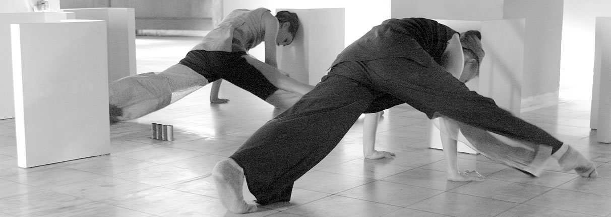

COMPANY DESCRIPTION www.amdat.org

AMDaT (www.amdat.org) is a New York City-based Dance/Arts Company established in 1998 by choreographer and visual artist Andrea Haenggi. The Company creates and produces visual motion constructions: site-specific dance video installations and site-integrated multimedia stage works that combine contemporary dance with visual art, prosaic architecture and technology. Through the development of new works and their presentation, often in non-traditional sites and public spaces, the Company challenges and engages its audience in rich, thought-provoking aesthetic experiences and aims to transform peoples’ perception of everyday life.

Haenggi's choreographic language involves the 360-degree geometry of the body developed in relation to the flat/horizontal/vertical screen of a moving digital image in space. Her works are inspired by prosaic architecture and the restriction of space. The process pursues the meaning of place in historical, emotional, spatial and social contexts. Very often Haenggi with her Company AMDaT brings visual motion constructions to non-traditional venues and public environments. In this, the Company’s aim is to challenge conventions and to bring this art form to people not normally exposed to it – breaking down the barrier between art and life. Andrea Haenggi with her company AMDaT recently premiered the evening-length work, escalator (March 2006) for seven dancers and four live musicians. The work was commissioned by World Financial Center Arts & Events for the lobbies of the World Financial Center complex, and reached more than 1000 people in two days.

In 2004 Andrea Haenggi/AMDaT created the critically-acclaimed under whose control, co-produced by the Lower Manhattan Cultural Council and presented as part of LMCC’s SiteLines Festival in an abandoned retail store. Last year she created blast wall art (2005) for the Commodore Barry Park handball courts in Brooklyn, NYC. Haenggi and AMDaT were invited by TSEH Dance Agency in Russia to participate in the Russian Dance Theater Festival TSEH 05. This involved a rigorous 4-week residency that culminated in a series of performances at the Moscow State Museum, The New Tretyakov Gallery. The Company have also appeared at performance venues including Joyce SoHo, Construction Company Dance Gallery, P.S 122, Jazz at Lincoln Center (in the Samsung Media Roadshow), and in museums such as the Cooper Hewitt National Design Museum and MASS MoCA in North Adams, Massachusetts. In Fall 2006, AMDaT will be presented by Dance Theater Workshop (DTW) as part of the city – wide Europe Dream Festival with there new work Friction at DTW Bessie Schoenberg Theater.

It is very valuable for The Company to have the chance to share our creative research with other artists and the wider communities in which we live & work. Residency activities such as workshops, movement master classes, artist talks and other outreach programs are a fundamental part of AMDaT’s work in the U.S and abroad, and continue to inspire and inform Haenggi’s movement and visual research.

This visual motion construction should shed new meaning on our sense of space – of our own location in the world. Every wall, every corner, every chunk of flaking paint, every flickering shadow thus becomes part of the performance.

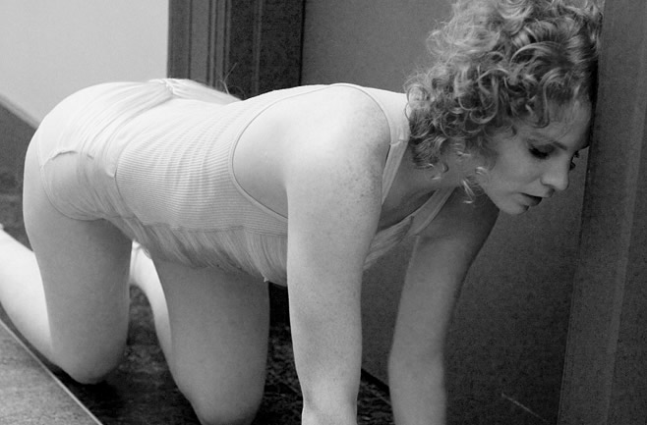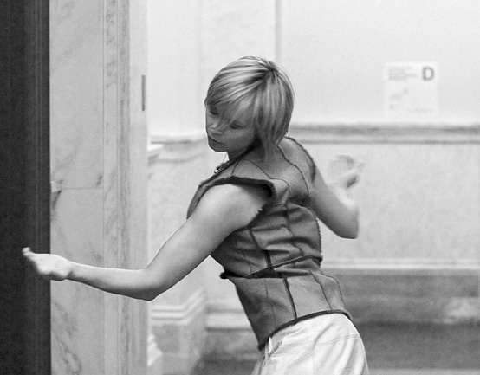

PERFORMANCE SCHEDULE 2006

Dance Theater Workshop Fall/Winter Season, NYC October 24-28

As part of the European Dream Festival
New Work: Friction

- Open for Dancing Festival, Newport, Rhode Island September 23/24
New Work: The Yellow Ball
Commissioned by Island Moving Dance Company

- White Oak Plantation Company Residency, Florida August 28-Sept.12

Idea in Motion Festival, Boston April 20
10 minute work: «surveillance»

- DTW Digital Fellowship Presentation, NYC March 28

- World Financial Center Arts & Events, NYC March 10+11
New Work: escalator
Commissioned by WFC Arts & Events

92Y noon & series Feb. 17
Facettes of escalator

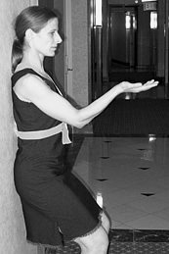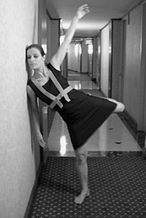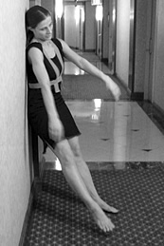

ANDREA HAENGGI - ARTISTIC DIRECTOR AMDaT - BIOGRAPHY

Andrea Haenggi, a New York-based Swiss born a choreographer, visual artist, performer and the artistic director/founder of AMDaT, a Dance Arts Company that creates and produces live-performances of visual motion constructions: site-specific dance video installations and multimedia stage works that combine contemporary dance with visual art, prosaic architecture, and technology. The winner of a 2005 Digital Arm Fellowship from Dance Theater Workshop, Ms. Haenggi was recently commissioned by World Financial Center Arts & Events to present with her Company AMDaT her new work, escalator, specially designed for the public lobbies of the World Financial Center Complex in New York City in March 2006.

Ms. Haenggi pursued professional dance studies at the Jutta Klamt School and CH-Tanztheater in Zurich and continued her training at the Martha Graham School of Contemporary Dance in New York City. After concluding her studies, she performed with many diverse companies, but the biggest influence on her current concept of choreography is Alien Action, Erin McGonigle’s series of performance-invasions in unusual locations in New York from 1996-1998. Meanwhile, Haenggi continued to pursue her longtime passion for visual art, which she sees as another sort of dance, "moving colors around within the square of a canvas".

One day she asked herself: What happens to the experience of a digital image or a painting if it moves like a dancer? This was the genesis of the complex dance/art installations she calls visual motion constructions, and resulted in the birth of her first production, al+one in a room with her company AMDaT (Andrea Maria Dance art Technology) in 1998. She was immediately invited to restage the work at MASS Mo CA, one of America’s leading contemporary art museums. The founding of AMDaT has led Haenggi to eight years of artistic activity in which she has created nine full-length works, numerous shorter pieces, and a series of community residencies in which she continues to discover her unique voice through the meeting points between movement, video imagery, and architecture. Her work has been presented by festivals and presenting organizations in the United States, Russia, Switzerland, Canada and the Czech Republic.

As AMDaT’s Artistic Director, Haenggi has collaborated with numerous arts presenters, musicians, designers and a core group of 4 to 7 dancers to create and produce visual motion constructions. In the past few years, she has focused increasingly on creating site-integrated dance video installations for non-traditional and public spaces. In 2004, she created the critically-acclaimed under whose control, co-produced by the Lower Manhattan Cultural Council and presented as part of LMCC’s SiteLines Festival in an abandoned retail store. In 2005, Haenggi was invited by TSEH Dance Agency in Russia to participate in the Russian Dance Theater Festival TSEH05. This involved a rigorous 4-week residency that culminated in a series of performances at the Moscow State Museum The New Tretyakov Gallery. Other public installation works include blast wall art (2005) for the Commodore Barry Park handball courts in Brooklyn, squaring the circle (2001), a community project for Brooklyn’s Maria Hernandez Park, and echo chamber (1999) created for a squatter house in Prague, Czech Republic.

Haenggi is in the process of choreographing Friction with her company AMDaT; the piece is a new site-integrated multi media stage work with a commissioned score by David Linton. The work is commissioned and will be presented by Dance Theater Workshop in October 2006. She has also been commissioned by Island Moving Company (Newport, RI) to create a site-specific work for their company to be presented during the Newport Festival “Opening for Dancing” in September 2006.
She has taught body is the screen – her choreographic lab workshop at the Performing Arts Center Tanzhaus Wasserwerk in Zurich, Switzerland, Dance Step Studio, London Ontario, and at the On View Studio, Brooklyn, NYC. Haenggi received an artistic and Company residency at the White Oak Plantation funded by the Howard Gilman Foundation (2005/06) and Tanzhaus Wasserwerk, Zurich, Switzerland.

AMDaT COMPANY DANCERS BIOGRAPHIES

Einy Aam received her BA (Hons) from London Contemporary Dance School in 2001, and has worked with AMDaT since March 2004. While in New York she has also performed for Noemie Lafrance in two productions of the Bessie Award winning Descent (2002 and 2003) and in Noir (2004). In Norway, she recently choreographed and performed for the musical concert Tree of Tenderness by composer Magnar Aam, and has also collaborated with Torill Haugen on the dance films “From Dust till Dawn” and “Here, in the Resurrection” and is featured in Marco Ruffatti's dance film “Linescapes v.! Norway.”

Jeff Crumrine received ballet lessons and a motorcycle a the age of six. He has continued with both ever since. Jeff graduated from Interlochen Arts Academy in 1997 and from S.U.N.Y. Purchase in 2002. In New York City he has performed with the Eric Hawkins Dance Company, Noa Dance, Syren, and Noemie Lafrance's Sens Productions and performs with AMDaT since 2005.

Tori Sparks has been a member of AMDaT since 2002, and has toured Russia, Switzerland and Germany with the Company. She has performed principle roles in Noemie Lafrance's Noir and Bessie-Award winning Descent. She has collaborated with visual artist Julia Mandle with featured roles in Feast, among many others. Together with Dutch choreographer Beppie Blankert, she is developing the role of Harmony Ives in Norman MacAfee's opera, The Death of the Forest. Other endeavors include installations & films by Tunga, Michelle Handelman, and Andrew Einhorn. Visit www.sharpelbow.com for information regarding Tori's current endeavors and her latest dance video, Lovebirds.

Uta Takemura received her B.F.A. from the State University of New York at Purchase and her M.F.A. from New York University's Tisch School of the Arts where she was a recipient of the Seidman Award for Dance. She has performed with various choreographers in New York City and has taught in Spain, France and Portugal. She currently dances with Mark Morris Dance Group, FREEFALL, and Wil Swanson/DanceWorks and joined AMDaT in Janurary 2006.

Seth Williams was raised in Davis, California and graduated with honors in Comparative Literature and Dance from UC Irvine. He has also appeared with the Mark Morris Dance Group, the New York Baroque Dance Company, and the Sean Curran Company. He has reconstructed baroque ballets from the18th-century Feuillet notation, and taught masterclasses and residencies at studios and colleges across the country. His politics and arts blog, www.takenasread.com, has received national attention, including mention in Slate and the Columbia Journalism Review.

COLLABORATORS

KAREN YOUNG COSTUME DESIGNER

Karen Young has designed costumes for many dance/theater companies, as well as visual artists in New York. She also worked as the head costumer of the Martha Graham Dance Company. In addition to her work with AMDaT, she has designed costumes for Elisa Monte Dance, the Juilliard Dance Ensemble, Ice Theater of New York, Philadanco, Nai-Ni Chen Dance Company, Cleveland Public Theater, and artist Matthew Barney's "Cremaster 5", among many others. Recent projects include: artist Toni Dove's interactive feature film "Spectropia", "The Trojan Women" at Toni Morrison's Princeton Atelier with Allegra Kent and Maria Tucci, and Eve Sussman's video installation “89 Seconds at Alcazar” at the 2004 Whitney Biennial.

DAVID LINTON COMPOSER/SOUND DESIGNER

David Linton is a 25-year plus veteran of the downtown NYC experimental music/multimedia community. From his early work on drums with Rhys Chatham, Glenn Branca, Elliott Sharp, (among others), through his many subsequent sound design/compositional collaborations – starting with Karole Armitage in the early 1980's, and progressing through 15 years of works for the Stephen Petronio Co., among others, and in addition to fruitful theatrical asides with the Wooster Group, he has applied constant 'pedal to the metal' regarding emergent innovative developments in the fine art of the soundscore. This is his 2nd piece with Andrea Haenggi/AMDaT.
A partial history of his more recent foray into audio-visual multimedia performance is available at www.unitygain.org

RICK MURRAY LIGHTING DESIGNER

Roderick Murray’s lighting designs have been seen nationally and internationally since 1992 on the works of Kimberly Bartosik, Wally Cardona, Ralph Lemon, Benjamin Millepied, Yanira Castro, Luca Veggetti, Scotty Heron, Pepatian, Hot Mouth, Donna Uchizono, Risa Jaroslow and Dancers, Bill Young and Dancers, Dusan Tynek, Kriota Willburg, among many others. He received 2001 Bessie Award for his work for Wally Cardona's Trance Territory. He is thrilled to be working this coming year with Dusan Tynek, Andrea Haenggi/AMDaT, and Paradigm Dance. He will also design Sekou Sundiata's newest work which is scheduled for its New York premiere next fall at the BAM Next Wave Festival. Prior to dedicating himself full time to design, he performed for 9 years with the award-winning Circus Amok.

AMDaT PERFORMANCE HISTORY 2005-1999

Lab Performance, correre I+II at Tanzhaus Wasserwerk, Zurich Dec 13, 2005

Residency, correre I+II at Tanzhaus Wasserwerk, Zurich (Switzerland) Dec 5-12, 2005

TSEH Dance Theater Festival, Moscow Nov 30-Dec 4, 2005
new version of under whose control

Residency at the TSEH Dance Agency, Moscow (Russia) Nov 1-29, 2005

DTW 40 Forward; NYC Nov 7, 2005
new work: ”revolving”

Samsung Global Roadshow, NY Oct 25, 2005
ring tone, a 10 minute work

Artward Bound, White Oak Plantation Residency, Florida Jul 1-10, 2005

Commodore Barry Park Handball Courts, Brooklyn, NY Jun 15-18, 2005
new work: blast wall art

New York Sheraton Hotel 5th floor corridor; APAP Conference NYC Jan 9, 2005
Introduction to New Work correre I+II (8 performances)

P.S 122 Hothouse, Improvisation work, group showcase, NYC Nov 22, 2004

SiteLines Festival, former J&R cigar store in Lower Manhattan Jun 16-26, 2004 Presented and Co-commissioned by Lower Manhattan Cultural Council (15 performances)
under whose control, a 55 minute dance video installation (a new incarnation)

APAP Conference 2004, NYC, Construction Company Gallery Showcase Jan 9-10, 2004
Excerpt: the ninth situation-2

DUMBO Dance Festival, White Wave Studio, group showcase, NYC Oct 18, 2003
untitled No. 1, a 10 minute work

Treffpunkt Rotebuehlplatz, Stuttgart, Germany July 10-11, 2003
Presented by Treffpunkt Rotebuehlplatz
the ninth situation-2, re-staged, an hour dance work for the theatre

New York Swiss Peaks Festival, On View Studio, Brooklyn April 12, 13/19-20
Produced by AMDaT April 26-27, 2003
under whose control, first version (three performances a day)

Swiss Ambassador Residency, NYC Dec 17, 2002
blind alley, site-specific dance installation, a 15 minute solo

P.S 122 Hothouse, Improvisation work, group showcase, NYC Dec 2, 2002

Construction Company Dance Gallery, NYC Oct 27-28, 2002

Presented by Construction Company
the ninth situation-2, re-staged, an hour dance work for the theatre

Dancenow NYC Festival, John Jay College Theatre, group showcase Sept 8, 2002
Je suis l'espace ou je suis NO.2, a 10 minute solo

Dance Access, St. Marks Church in the Bowery, NYC Sept 5-7, 2002
Commissioned by Dankmeyer Dance Company
fallen, a looping site specific dance video installation (35 minute)

London Fringe Festival, Ontario, Canada Aug 10–18, 2002
Presented by London Fringe Festival (6 performances)
the ninth situation-2, an hour dance work for the theatre

Maria Hernandez Park, community project, Bushwick, Brooklyn, NYC Oct 13/14/20/21,2001
squaring the circle, a interactive outdoor dance installation, 60-minute work (8 performances)

WAX Theater, Williamsburg, NYC April 27-29, 2001
a new basis for mental agitation, shared program

MASS MoCA, Massachusettes Contemporary Art Museum, North Adams Jan 25, 2001
Presented by MASS MoCA (two performances)
al+one in a room #2, re-staged

Joyce SoHo Theatre, NYC June 1-4, 2000
cradle rocking in quicksand, a 60-miute dance video work

Milada Culture Center, Prague, Czech Republic March 12, 1999
echo chamber, 40-minute solo work,

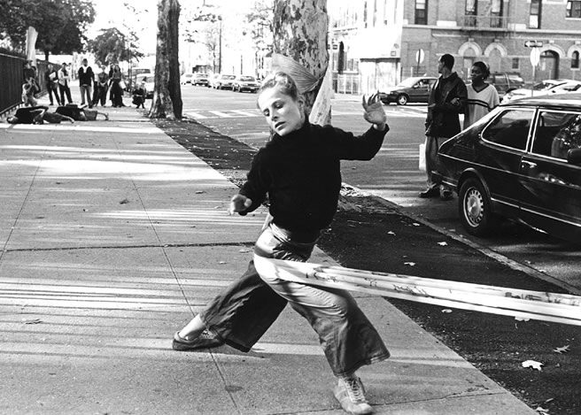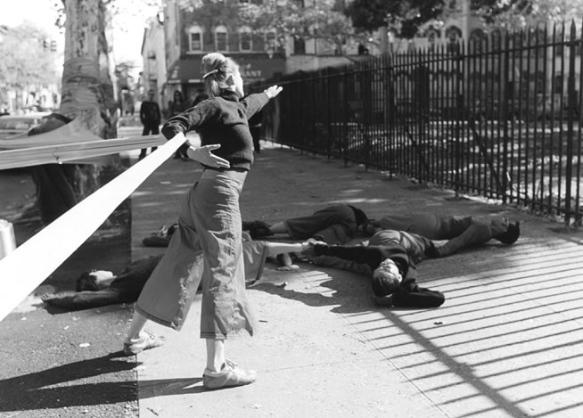

HISTORY AND ORGANIZATION OVERVIEW

Choreographer, dancer and visual artist Andrea Haenggi formed her company, AMDaT in 1998. Recent recognition of Haenggi’s Contemporary Dance Arts Projects in the USA and abroad have accelerated the necessity for a solid company structure within which to produce, expand and co-ordinate her projects. In June 2003, AMDaT was formally Incorporated as AMDaT, Inc. and got her tax-exempt 501 (c) (3) status in July 2004. AMDaT, Incorporated administers the activities of Andrea Haenggi and AMDaT Company. The organization oversees a variety of activities including producing and performing new productions, touring to international venues and administering independent choreography commissions for Andrea Haenggi.

BOARD OF DIRECTORS

President/Founder Andrea Haenggi, Artistic Director AMDaT
Vice – President/Secretary Rebecca Guber, Executive Director, Hazon. Inc.
Treasurer Nancye Good, Executive Director, Milky Way Film Production, Inc.

AMDaT TEAM

Director, Choreographer, Visual Artist Andrea Haenggi
AMDaT Company Members Einy Aam, Jeff Crumrine, Tori Sparks, Uta Takemura, Seth Williams
Development Consultant Kate Taylor
Europe Tour Management Martina Alfonso
Intern Tara Burns

