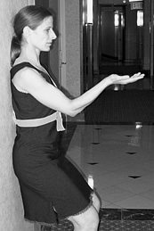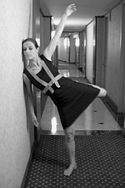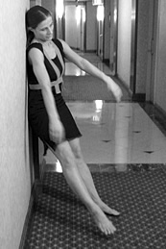

ANDREA HAENGGI - ARTISTIC DIRECTOR AMDaT - BIOGRAPHY

Andrea Haenggi, a New York-based Swiss born a choreographer, visual artist, performer and the artistic director/founder of AMDaT, a Dance Arts Company that creates and produces live-performances of visual motion constructions: site-specific dance video installations and multimedia stage works that combine contemporary dance with visual art, prosaic architecture, and technology. The winner of a 2005 Digital Arm Fellowship from Dance Theater Workshop, Ms. Haenggi was recently commissioned by World Financial Center Arts & Events to present with her Company AMDaT her new work, escalator, specially designed for the public lobbies of the World Financial Center Complex in New York City in March 2006.

Ms. Haenggi pursued professional dance studies at the Jutta Klamt School and CH-Tanztheater in Zurich and continued her training at the Martha Graham School of Contemporary Dance in New York City. After concluding her studies, she performed with many diverse companies, but the biggest influence on her current concept of choreography is Alien Action, Erin McGonigle’s series of performance-invasions in unusual locations in New York from 1996-1998. Meanwhile, Haenggi continued to pursue her longtime passion for visual art, which she sees as another sort of dance, "moving colors around within the square of a canvas".

One day she asked herself: What happens to the experience of a digital image or a painting if it moves like a dancer? This was the genesis of the complex dance/art installations she calls visual motion constructions, and resulted in the birth of her first production, al+one in a room with her company AMDaT (Andrea Maria Dance art Technology) in 1998. She was immediately invited to restage the work at MASS Mo CA, one of America’s leading contemporary art museums. The founding of AMDaT has led Haenggi to eight years of artistic activity in which she has created nine full-length works, numerous shorter pieces, and a series of community residencies in which she continues to discover her unique voice through the meeting points between movement, video imagery, and architecture. Her work has been presented by festivals and presenting organizations in the United States, Russia, Switzerland, Canada and the Czech Republic.

As AMDaT’s Artistic Director, Haenggi has collaborated with numerous arts presenters, musicians, designers and a core group of 4 to 7 dancers to create and produce visual motion constructions. In the past few years, she has focused increasingly on creating site-integrated dance video installations for non-traditional and public spaces. In 2004, she created the critically-acclaimed under whose control, co-produced by the Lower Manhattan Cultural Council and presented as part of LMCC’s SiteLines Festival in an abandoned retail store. In 2005, Haenggi was invited by TSEH Dance Agency in Russia to participate in the Russian Dance Theater Festival TSEH05. This involved a rigorous 4-week residency that culminated in a series of performances at the Moscow State Museum The New Tretyakov Gallery. Other public installation works include blast wall art (2005) for the Commodore Barry Park handball courts in Brooklyn, squaring the circle (2001), a community project for Brooklyn’s Maria Hernandez Park, and echo chamber (1999) created for a squatter house in Prague, Czech Republic.

Haenggi is in the process of choreographing Friction with her company AMDaT; the piece is a new site-integrated multi media stage work with a commissioned score by David Linton. The work is commissioned and will be presented by Dance Theater Workshop in October 2006. She has also been commissioned by Island Moving Company (Newport, RI) to create a site-specific work for their company to be presented during the Newport Festival “Opening for Dancing” in September 2006.
She has taught body is the screen – her choreographic lab workshop at the Performing Arts Center Tanzhaus Wasserwerk in Zurich, Switzerland, Dance Step Studio, London Ontario, and at the On View Studio, Brooklyn, NYC. Haenggi received an artistic and Company residency at the White Oak Plantation funded by the Howard Gilman Foundation (2005/06) and Tanzhaus Wasserwerk, Zurich, Switzerland.

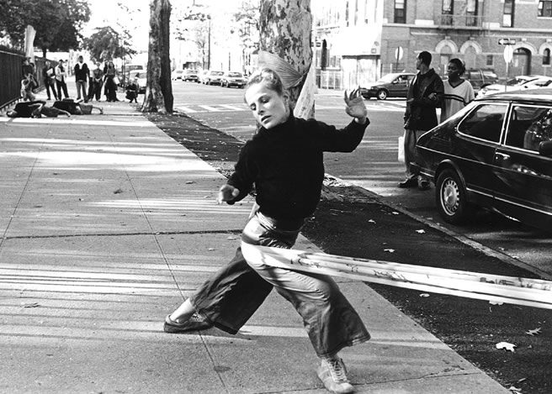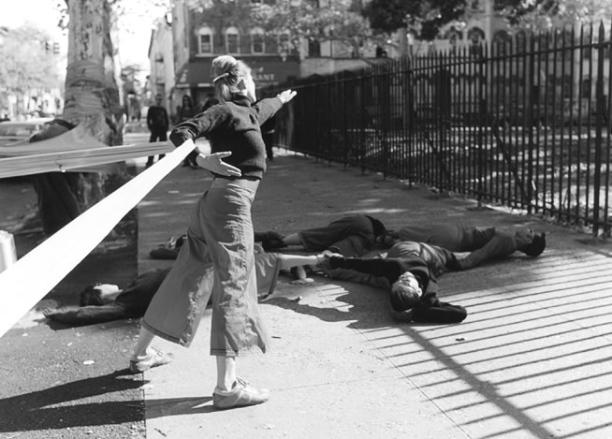

HISTORY AND ORGANIZATION OVERVIEW

Choreographer, dancer and visual artist Andrea Haenggi formed her company, AMDaT in 1998. Recent recognition of Haenggi’s Contemporary Dance Arts Projects in the USA and abroad have accelerated the necessity for a solid company structure within which to produce, expand and co-ordinate her projects. In June 2003, AMDaT was formally Incorporated as AMDaT, Inc. and got her tax-exempt 501 (c) (3) status in July 2004. AMDaT, Incorporated administers the activities of Andrea Haenggi and AMDaT Company. The organization oversees a variety of activities including producing and performing new productions, touring to international venues and administering independent choreography commissions for Andrea Haenggi.

BOARD OF DIRECTORS

President/Founder Andrea Haenggi, Artistic Director AMDaT
Vice – President/Secretary Rebecca Guber, Executive Director, Hazon. Inc.
Treasurer Nancye Good, Executive Director, Milky Way Film Production, Inc.

AMDaT TEAM

Director, Choreographer, Visual Artist Andrea Haenggi
AMDaT Company Members Einy Aam, Jeff Crumrine, Tori Sparks, Uta Takemura, Seth Williams
Development Consultant Kate Taylor
Europe Tour Management Martina Alfonso
Intern Tara Burns

